The Dojo of Oldsmar

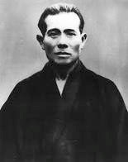
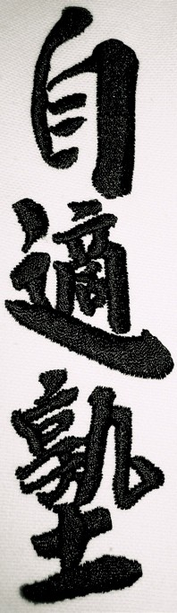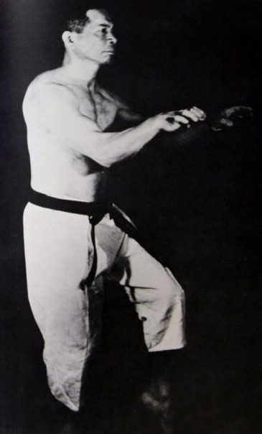
Master Kanbun Uechi
Master Kanei Uechi

Uechi Ryu Student Manual

Welcome Letter
Vision and Mission Statments
Uechi Ryu History
Dojo Rules and Etiquette
Kyu Belt Ranks
Kyu Testing Requirements
Junior Blackbelt Ranks
Junior Blackbelt Testing Requirements
Dan Ranks
Dan Testing Requirements
Uechi Ryu Katas
Sanchin
Hojo Undo
Junbi Undo
Dan Kumite
Uechi Ryu Specialty Strikes
General Knowledge Questions for White belt with Yellow Tip
General Knowledge Questions for Yellow Belt
General Knowledge Questions for Yellow Belt with Green Tip
General Knowledge Questions for Green Belt
General Knowledge Questions for Green Belt with Blue Tip
General Knowledge Questions for Blue Belt
General Knowledge Questions for Blue Belt with Brown Tip
General Knowledge Questions for Brown Belt
General Knowledge Questions for Brown Belt with Black Tip
Vocabulary

Welcome
Welcome to our school . We are honored that you have chosen our school for your karate and martial arts training. You have just made an important decision that will affect your life positively by starting down the path of martial arts training. Everyone here is committed to helping you on this journey.
The first few months of any martial arts training can be, without a doubt, difficult and awkward. The key to success is being patient and going at a pace with which you are most comfortable. In time, however, the study of the martial arts will show you how much you can really do and achieve! It is very exciting!
Please discuss any questions you may have with your instructor. A student’s questions and any personal concerns will be kept confidential and we will work diligently to answer questions and resolve any concerns.
This manual is meant to supplement your training, but not replace it. It is an organic document that we regularly update and work to improve, just like your training. It is never finished and there is always room for improvement. We hope that you too will find inspiration in your Uechi Ryu training and that 30 years from now you will still be learning and improving.

Self Reliance
One shall pursue true passage of his or her own doctrine. One’s sorrow and joy should not be affected by the condemnation or praise by others. Self reliance (belief) is the true nature of true being.

Vision
The Dojo of Oldsmar works to develop and nurture a community of self-reliant martial artists who are devoid of ego and self-interest and dedicated to a life of strengthening body, mind and spirit. We are committed to upholding the principles and traditions of Uechi-Ryu Karate Do through the teachings of Master Kanei Uechi.

Mission
Through the study of Okinawan Uechi-Ryu Karate Do, we seek a path that supports all students to improve themselves through the practice and mastery of the technical, mental and spiritual principles to provide examples for future generations. To always keep sacred the traditions of dojo conduct and decorum.

Disclaimer
The Authors and publisher of this manual are NOT RESPONSIBLE in any manner whatsoever for any injury which may occur through the reading or following the instructions in this manual. The activities, physical or otherwise are too strenuous or dangerous for some people, and the reader(s) should consult a physician before engaging in them.

Uechi Ryu History
The history of Uechi-Ryu Karate-do is incomplete at best. Because the style was derived from several different arts in China, which were not written down, we must gather what we can, remember it, and pass on to future students.
The founder of Uechi-Ryu was an Okinawan named Kanbun Uechi. He was born in 1877 to a family of samurai status, but since the occupation of Okinawa in the 1600s by the powerful Satsuma clan from the island of Kyushu on mainland Japan, this status was taken away. The Uechi family turned to farming to make a living on the northern side of the island.
As Kanbun grew, so did his interest in the martial arts. It is said that he became quite good with the bo (6 foot staff). When he turned 18 and became old enough to be drafted into the Japanese army (1897), he and his parents decided that the best course of action would be for him to leave Okinawa for China. At the time, many Okinawans felt oppressed by the Japanese invaders and did not feel it was right that they should be forced to fight for what they felt was another country. As a result, many young men left for China where there was a strong historical tie between the two peoples. So, in 1897, Kanbun left Okinawa for Fuzhou city in southern China (Fukien Province).
After a short adjustment period, Kanbun began to study Chinese Kenpo (Pangainoon) under the famous Chinese master Zhou Zi He (Shu Shi Wa in Japanese). He studied under Zhou Zi He for ten years, becoming fluent in the Chinese language and proficient in Chinese medicine. After receiving a teacher’s certificate in 1904, Kanbun became one of the first non-Chinese to teach Pangainoon in China when he opened his own school in the province of Nansoue. He had been warned by the villagers that it was unwise to open a school there as several people had already tried and failed. In time, however, Kanbun Uechis reputation grew to the point that he was able to develop a very successful school. Then, one of his students, who was quiet and unassuming by nature, got into a fight with someone over a border dispute and killed him in self-defense. Unfortunately, the people of the village blamed Kanbun for teaching the student, which forced him to leave China after thirteen years.
Kanbun returned to Okinawa in 1910 at the age of 33, and vowed never to teach karate again. He became a farmer, married Gozei Toyama, and eventually had four children (two boys and two girls): Kanei (1911), Tsuru, Kame, and Kansei. After two uneventful years, an old student of his from China came to Okinawa and tried to convince Kanbun to teach again but with no success. When Kanbun’s old student got into a fight with one of the area’s karate masters and defeated him, people asked from whom he learned his karate. He told them that Kanbun Uechi was the real teacher and people should seek him out. Kanbun Uechi’s reputation in Okinawa grew, even though no one had seen him do anything. When people asked him to teach them, he denied any knowledge of the martial arts. When the townspeople finally confronted Kanbun with his old student, he could no longer deny it, but still he refused to teach.
Every year the local police department held a large martial arts demonstration where the local karate masters displayed their talent. The other karate masters, who were anxious to see Kanbun perform, asked the mayor of the city to ask that Kanbun participate. Uechi did not feel it would be proper to refuse a request from the mayor and when forced to perform in front of all of his peers, he performed an awe-inspiring Seisan kata, which was said to be his favorite. Due to the great skill of his demonstration, nobody wanted to perform after Kanbun Uechi, and the festival ended. Uechis reputation grew so much after that, that he was asked by Itosu Anko, a great karate expert in Shorin-Ryu, to teach karate at the teachers college in Okinawa. There was so much pressure, that the quiet and modest Kanbun Uechi left for Wakayama, Japan.
Kanbun found a job at a spinning mill and lived beside it in a housing development for fellow Okinawans. There he met a young Okinawan named Ryuyu Tomoyose, who for some reason suspected that Kanbun knew karate. Tomoyose would make up stories concerning make-believe fights and tell them to Uechi, who would then tell Tomoyose what he should have done during the fight. Tomoyose tried to convince Kanbun to resume teaching, but he continued to refuse. Finally, after two years, Kanbun agreed to teach again. Tomoyose recruited other Okinawans around the mill and soon Kanbun Uechi had a flourishing school of several hundred students. His most important student was his oldest son Kanei, who trained for ten years before returning to Okinawa to open his own school in Nago. In 1949, Kanbuns students renamed the style Uechi-Ryu in the Master’s honor.
Kanbun taught in Wakayama until 1946 when he returned to Okinawa. He handed over his school (Pangainoon-ryu Karate-jutsu Kenkyu-jo) to Ryuyu Tomoyose, and re-opened Kanei’s school in Nago which had been closed during the war. Kanbun taught for two more years until he fell ill with a liver problem at the age of seventy-one. However, because a fortune-teller had once told him that he would live until his eighties, he refused to see a doctor, and died on November 25, 1948, on the island of Ie-Jima off the coast of Okinawa. It is rumored that on the day that Kanbun Uechi died, his pain was so intense that he jumped out of bed and got into a sanchin stance because it was the only position where he felt no pain, and then died.
Kanei moved to Ginowan City a year later and opened a school that his students had built for him. In 1956, he moved his school and family (three boys and three girls) to Futenma, which is still the headquarters of the Uechi-Ryu Karate
Association. Kanei continued to teach in Okinawa, and in the 1950s was one of the first Okinawans to teach karate to foreigners.
During the 1960s, Uechi-Ryu Karate-do grew tremendously around the world due to the efforts of Kanei Uechi, who was awarded judan (tenth degree) in 1967 by both the Zen Nihon Karate-do Renmei (All Japan Karate Federation) and the Zen Okinawa Karate-do Renmei (All Okinawa Karate Federation). It was during the 1950s and 60s that many of the supplemental exercises were added such as, junbi undo, the warm up exercises, and hojo undo, the technical drills, the five intermediate katas, and the Kyu and Dan kumites.
Kanei Uechi was very much like his father, humble and unassuming. He was respected by his students as well as his peers in the martial arts. He showed interest in all his students including his American "children." Kanei made two separate trips to the United States, once in 1967 and the other in 1984 to check on the progress of Uechi-Ryu in America. He also traveled to Taiwan and China in an attempt to discover the origins of Pangainoon.
Kanei continued to lead the Uechi world until his death on February 24, 1991. He was 80 years old. Since then, the Uechi-Ryu system has split up into several different organizations.

Instructor Gerry Hendewich

Gerry Hendewich is a distinguished martial artist with the rank of 7th Dan in Uechi-ryu Kenyukai. His journey began in 1983 in Hartford, CT, under the tutelage of Master John Spencer, to whom he has remained a dedicated student ever since. His formative years were also shaped by influential sensei’s such as Ernest Harriman, John Griffin, and Alan C. Rosetto.
Over his extensive career, Mr. Hendewich has broadened his expertise to include other disciplines. He studied with Master Jon Palais (ITF Taekwondo), trained in Wing Chun for five years with Sifu Tony Koleczek, and for the last three years, has been learning Black Flag Kung Fu under Suhu John Hackmeyer. After moving to Florida, he also received his Shihan certificate and 5th Dan from Grandmaster Shinyu Gushi.
An accomplished competitor throughout the 90s and early 2000s, he achieved numerous top-three finishes in both kata and sparring at local, national, and international tournaments. His competition career culminated in a major victory when he won the Sparring Grand Championship at George Mattson's 2001 World Tournament in Boston.
Today, Mr. Hendewich is the co-owner of the Oldsmar dojo alongside Sensei Mark McElroy. Tasked with continuing the dojo's legacy from Sensei Ryan Dean and its founder, Master Frank Gorman, they are committed to upholding its tradition of high-quality instruction for years to come.

Instructor Mark McElroy

Mark McElroy is a seasoned martial artist and a 4th degree black belt in Uechi-ryu karate. His journey in martial arts began at the age of 12, leading him to achieve his 1st degree black belt in Goju-ryu karate by age 16. While serving in the U.S. Navy, he was a key member of the taekwondo team, where he won first place in the Armed Forces Championship and qualified for the World Championships.
In 2012, his career as a physical therapist in the U.S. Air Force took him to Okinawa, Japan—the homeland of karate. For five years, he immersed himself in the study of Uechi-ryu under the legendary Grandmaster Kiyohide Shinjo, famously known as the "Okinawan Superman."

Since 2017, Mr. McElroy has been an integral part of the Oldsmar dojo, where he is now a co-owner with Sensei Gerry Hendewich. Together, they are dedicated to sharing the authentic Okinawan style and heritage, fostering a true learning experience focused on guiding each student on their own true path.

Dojo Rules and Etiquette
- It is traditional for the teacher to be addressed as Sensei.
- It is traditional to bow before entering and when leaving the dojo (the bow acts as a reminder that the dojo is a place of hard work and where outside issues and concerns are left at the door).
- It is customary to wait to be recognized by the instructor before entering the practice floor if training is already in progress.
- The signal to the instructor that you wish to join the class is to sit Japanese style (knees forward, sitting on feet). A bow is acknowledgment that you have received the instructor's permission to join the class.
- During practice it is customary to request permission if one needs to leave the dojo. It is traditional for students and the sensei to bow to each other before and after training.
- It is traditional to bow to each other before and after training with other people (the bow is to show respect for each other and to show your intent is honorable).
- Behavior should be orderly. You are responsible for keeping your conduct under control both in and out of the dojo • There is no singing or whistling in the dojo.
- Keep talking to minimum while training.
- No food or drink are allowed in the dojo.
- Alcohol must not be consumed before training.
- Gi's should be clean and in good condition.
- Students are not to wear jewelry during practice.
- All karate-ka are expected to observe good personal hygiene, including clipped toe nails and finger nails where appropriate. Long hair should be tied back.
- Person to person relationships in the dojo must be reinforced with courtesy and friendliness.
- All male students must wear a cup during sparring.
- Students are to show respect for each other regardless of rank.
- Senior students have a duty to help junior students.
- No bullying or abusive behavior will be tolerated in the dojo.
- Shoes are not to be worn in the dojo.
- Always put equipment away properly when finished.
- All students have a responsibility to keep the dojo clean and tidy.
- Always strive to be humble and control your ego.

Kyu Ranks

- Jyuku
- Kyuku
- Hachikyu
- Shichikyu
- Rokkyu
- Gokyu
- Yonkyu
- Sankyu
- Nikkyu
- Ikkyu
- Kyu tests are held every 6 months
- As a guideline most students who practice consistently and diligently will be ready for testing
- Testing and ranks are not a rite or a guarantee; it's at Your Sensei's discretion
- A passing grade in all testing material is needed for promotion

Kyu Testing Requirements

Contents | White | White with  yellow tip | Yellow | Yellow with green tip | Green | Green with blue tip | Blue | Blue with brown tip | Brown | Brown with black tip
Sanchin
Kanshiwa
Kanshu
Seichin
Seisan
General knowledge
Hojo undo
Kote kitae
Sparring drills
Sparring
Kanshiwa bunkai
Seisan bunkai
Dan kumite

Junior Black Belt Testing

Contents | Sanchin Seisan Seiryu Kanchin Hojo Kanshiwa Seisan undo bunkai bunkai |  |  |  |  |  |  | Uke  demo | Sparring | Kote kitae
Jun shodan
Jun shodan
with yellow tip
Jun shodan
with 2 yellow tips
Jun shodan
with 3 yellow tips
Jun nidan
Jun nidan with green tip
Jun nidan with 2 green tips
Jun nidan with 3 green tips
Jun sandan
Jun sandan with blue tip
Jun sandan with 2 blue tips
Jun sandan with 3 blue tips
Jun yondan
Jun yondan with brown tip
Jun yondan with brown tip
Jun yondan with brown tip
*Jun Shodan, Jun Nidan, Jun Sandan, Jun Yondan
* Junior black belt tests are held during regular scheduled Kyu tests
*Junior black belts must successfully pass three tip test before they are eligible for a full junior rank
* It's a minimum of a year in between a Junior Black belt to achieve a full rank
* All students must be 16 years of age before they are eligible for official adult Black belt rank

Dan ranks

- Shodan
- Nidan
- Sandan
- Yondan
- Godan
- Rokudan
Masters Title Renshi
- Shiichidan or NanadanMasters Tittle Kyoshi
- Hachidan
Masters Kyoshi
- Kyudan
Masters Title Hanshi
- Judan
Masters Title Hanshi-sei
- In past versions both 7th and 8th were awarded 2 bars and 9th and 10th were 3 bars
- Our Okinawan teachers changed their senior master ranking system and we have done so also as to more easily distinguish the difference between senior master ranks
What does it mean to be a black belt

Thousands of hours training, hundreds of classes, countless bumps and bruises, One Black Belt. Being a black belt is a cause, a cross to bear, a responsibility, and an obligation. It is a banner that advertises that the wearer has worked hard at developing skills that are unique and that they are committed to important principles. Being a black belt is an invitation to deny one’s needs and step outside one’s self. It casts us in the role of teacher, protector, guide, and role model. It asks us to guard every word, and every action so that we do not betray its noble purpose. Being a black belt means that when you put on the belt you cannot take it off again and just be who you want to be when it’s convenient. You must wear it every hour of every day for the rest of your life, and you must be who the belt demands that you must be. Being a black belt means that from the day that you first wear it you must never dishonor another, and cannot shrink from your obligation to assist others in need. Unless a person has a back and legs strong enough to carry this burden they should not pick up the belt. But if you do pick up the belt, do so with the knowledge that it will lead you to places where others cannot go and you will see vistas reserved for the few, and life will be an experience well above the ordinary. Almost anybody can get a black belt. Not everybody can BE a black belt

Dan Testing Requirements
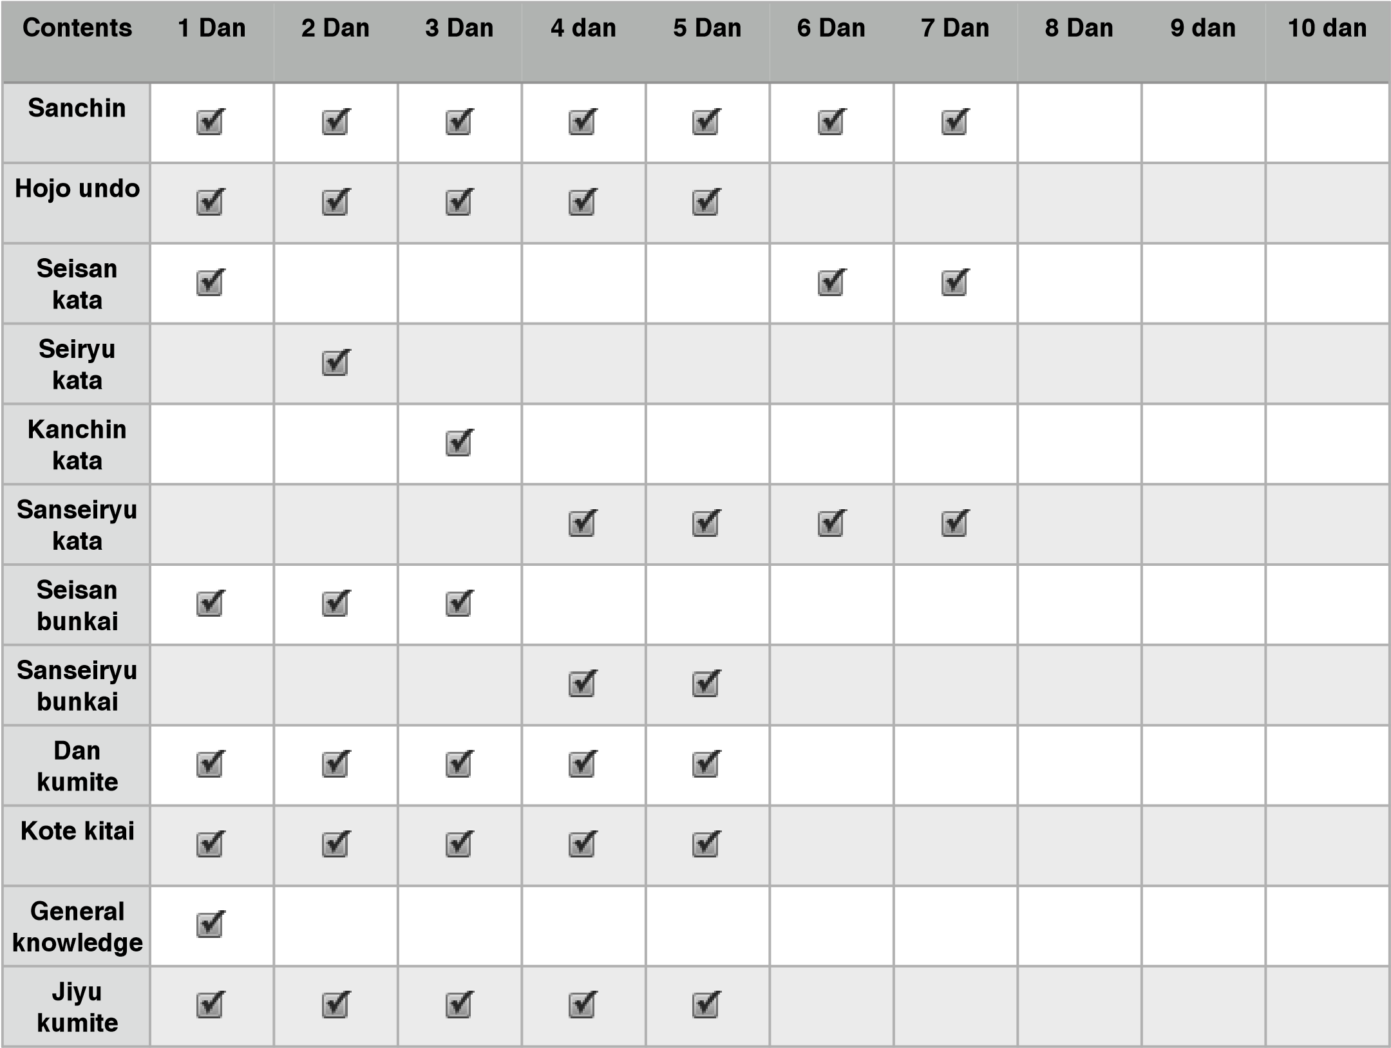

UECHI RYU KATAS

SANCHIN - KANSHIWA - KANSHU - SEICHIN
SEISAN - SEIRYU - KONCHIN - SANSEIRU

SANCHIN

“Three Conflicts”
MIND, BODY, SPIRIT SERVES AS BASIS OF THE ENTIRE SYSTEM
ONE OF THE THREE KATAS OF PANGAINOON BROUGHT FROM CHINA
BY KANBUN UECHI , ADDED TO SYSTEM IN 1948
SANCHIN KATA SERVES BASIS OF THE ENTIRE SYSTEM

KANSHIWA

“perfect peace unity”
NAME COMES FROM KANBUN + SHUSHIWA
ACCOMPANING BUNKAI
ADDED TO THE SYSTEM IN1956 BY KANEI UECHI

KANSHU
NAME COMES FROM KANBUN + SHUSHIWA
ADDED TO THE SYSTEM IN 1956 BY UEHARA SABURO

SEICHIN

“Ten Conflicts”
NAME COMES FROM SAISAN+SANCHIN
CONSIDERED BY SOME TO BE THE “WEAPONS KATA”
FOR ITS SIMILARITY TO KOBUDO TECHNIQUES
ADDED TO THE SYSTEM IN 1956 BY ITOKAZU SEIKI

SEISAN

“13 Conflicts”
ACCOMPANYING BUNKAI
ONE OF THE THREE KATAS OF PANGAINOON BROUGHT FROM CHINA BY KANBUN UECHI, ADDED TO SYSTEM IN 1948

SEIRYU

“Sixteen”
NAME COMES FROM SEISAN+SANSEI RYU
ADDED TO SYSTEM IN 1950 BY KANEI UECHI

KONCHIN

“perfect Battle”
NAME COMES FROM KANBUN + SANCHIN
ADDED TO SYSTEM IN 1960 BY KANEI UECHI

SANSEIRU

“Thirty Six Position Of Attack And Defence”
ACCOMPANYING BUNKAI
ONE OF THE THREE KATAS OF PANGAINOON BROUGHT FROM CHINA
BY KANBUN UECHI, ADDED TO SYSTEM IN 1948
•

Sanchin: The Foundation of Uechi Ryu Karate
In Uechi-Ryu, the kata Sanchin is the foundation for all that follows. It is truly the most important of the eight Uechi-Ryu kata studied today. As everyone knows, a structure without a good foundation will weaken and fall apart within a very short time. Sanchin, practiced as a dynamic tension kata, builds, strengthens, and hardens all muscles of the body.
The kata Sanchin was developed by Bodhidharma ( Japanese know him as Daruma Taishi) sometime around the 13th century. This kata has withstood the test of time and is practiced in other martial arts styles as well as Uechi-ryu.
Ueichi-Ryu students focus on the following five elements to achieve the most from Sanchin:
- Build a strong physique (Make your body as hard as you can)
- Consolidate the basic stance (So as to give yourself the most leverage)
- Master proper breathing (Know when and when not to breath)
- Penetrating eye (Acute keen insight and development of peripheral vision)
- Develop spiritual concentration (Think only of what you are doing at that moment)
Although Sanchin is the first kata learned in Uechi-Ryu, as one becomes a black belt he or she finds themselves still working on perfecting the movements. Periodically, a student is tested physically in Sachin. During this testing the instructor will strike key areas of the body checking the students balance and ability to focus certain muscle groups as a protective armor.
There is a karate legend that originated in China that can be directly related to Sanchin. There were three mythical gods known to be the best fighters in all of China. They were the gods of eyes, breathing, and posture. Individually they could be defeated. However, when fighting together they were unbeatable. When studying Sanchin one must strive to master these three characteristics. To only master one or two does not provide a complete defense. It is like building a house on two-thirds of a foundation.

SANCHIN BASIC POSITIONS

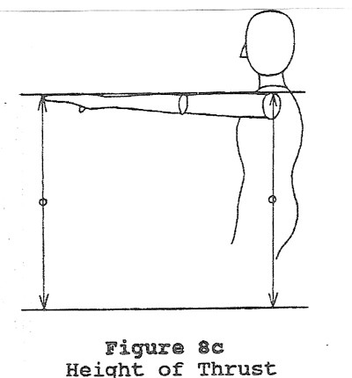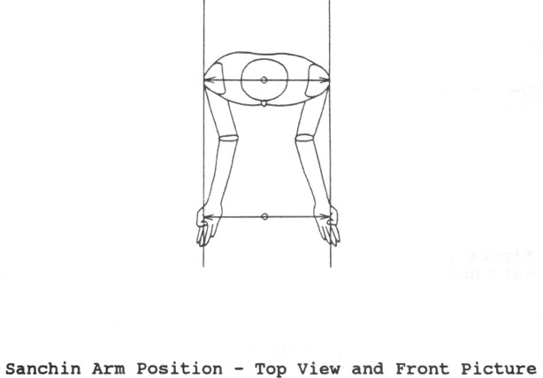
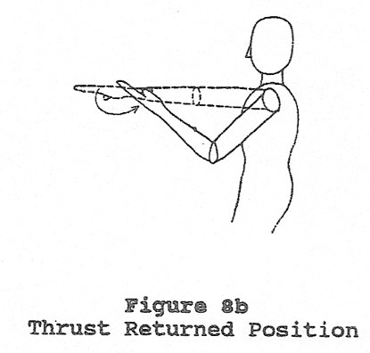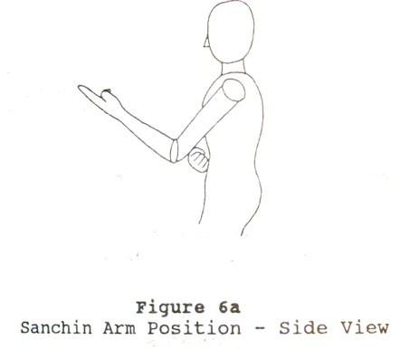
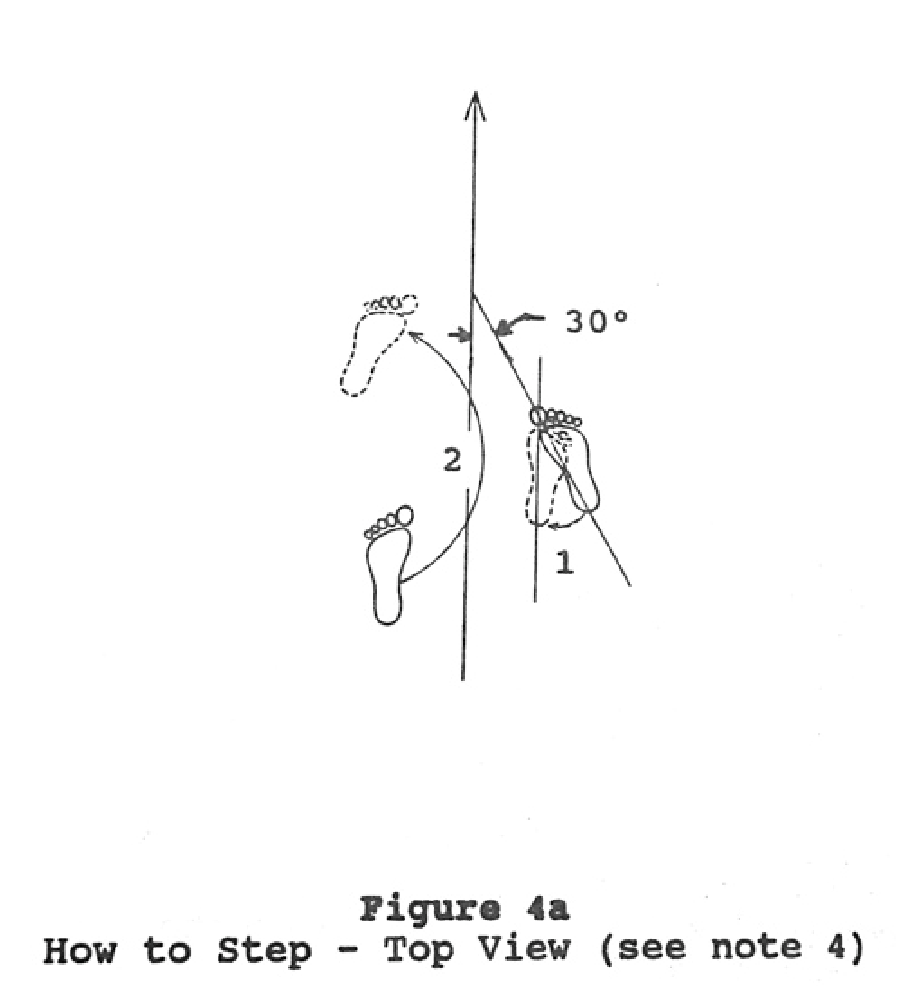
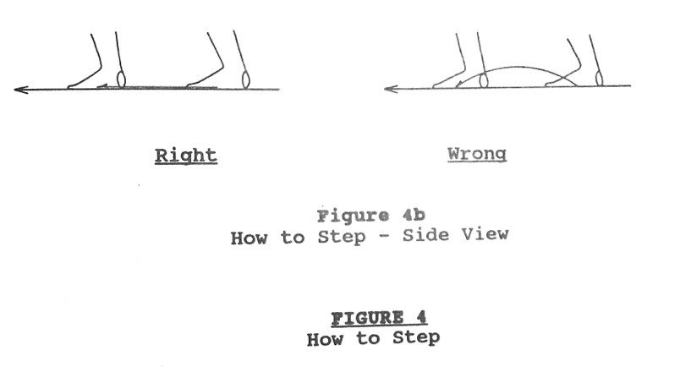
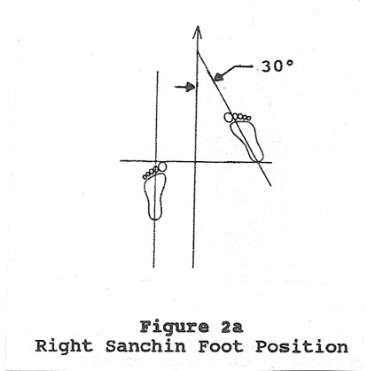
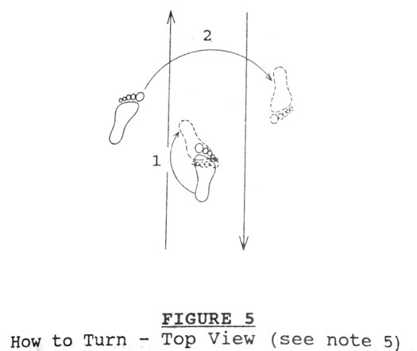
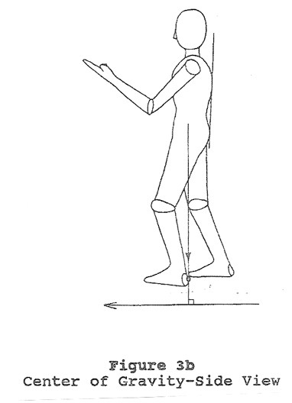
Hojo Undo
Sokuto Geri (SIDE KICK)
Right Sanchin stance, right circular block, right side snap kick, left circular block, left side snap kick.
Shomen Geri (FRONT KICK) Right Sanchin stance, right circular block, right front kick, left circular block, left front kick.
Hajuki Uke Hiraken Tsuki (SNAPPING BLOCK, FOUR KNUCKLE STRIKE)
Right Sanchin stance, right upper rising block, right half fist strike, right middle inner block, right half fist strike.
Mawashi Tsuki (CIRCLE HOOK PUNCH)
Right Sanchin stance, left circular block, right hook punch, right circular block, left hook punch.
Seiken Tsuki (STRAIGHT PUNCH)
Right sanchin stance, right circular block, left full fist punch, right palm heel block, left full fist punch.

Shuto Uchi Ura Uchi Shoken Tsuki
(CIRCLE BLOCK, CHOP, BACKFIST, ONE KNUCKLE STRIKE)
Right sanchin stance, left circular block, right chop, right backfist, right one knuckle punch. Step back into left stance and repeat on other side.
Hiji Tsuki (ELBOW STRIKE)
Right sanchin stance, left circular block, right elbow strike forwards, sidewards and to the rear.
Tenshin Zensoku Geri (TURN, FORWARD FOOT KICK)
Right sanchin stance, step forward into a right stance, at the same time turn 45 degrees to the left. Left circular block, right front kick. Step forward with left foot and make a 90 degree turn to the right. Step back with right foot finishing in a left stance. Right circular block, left front kick.
Tenshin Kosoku Geri (TURN, REAR FOOT KICK)
Left sanchin stance, step forward into a left stance, at the same time turn 45 degrees to the right. Right circular block, right front kick. Step forward with right foot and make a 90 degree turn to the left. Step back with left foot finishing in a right stance. Left circular block, left front kick.

Tenshin Shoken Tsuki (TURN, ONE KNUCKLE STRIKE)
Right sanchin stance, step forward into a right stance, at the same time turn 45 degrees to the left. Left circular block, right one knuckle punch, right circular block, left one knuckle punch. Step forward with left foot and make a 90 degree turn to the right. Step back with the right foot finishing in a left stance. Right circular block, left one knuckle punch, left circular block, right one knuckle punch.
Shomen Hajiki (FINGER TIP FLICK)
Left sanchin stance, slide step forward into left stance and block down, strike forward at eye level with fingertips. Slide back in a left stance, block down, strike forward at eye level with fingertips.
Koi No Shippo Uchi Tate Uchi (FISH TAIL STRIKE VERTICALLY)
Right sanchin stance, strike upwards, downward, outwards and inward with both hands.
Koi No Shippo Uchi Yoko Uchi (FISH TAIL STRIKE HORIZONTALLY)
Left sanchin stance, strike side to side with both hands, starting left.
• Hojundo Exercises can be performed beginning with either foot at Sensei`s Discretion

Junbi Undo Warm Up Exercises

- Ashi saki o ageru undo (heel pivot)
- Kakato o ageru undo (heel lift)
- Ashikubi o mawasu undo (foot and ankle twist)
- Hiza o mawasu undo (knee circular bend)
- Ashi o mae yoko ni nobasu undo (leg lift and turn)

- Ashi o mae uchi naname no ageru undo (straight left lift)
- Tai o mae ni taosu undo (waist scoop)
- Koshi no nenten (trunk stretch)
- Ude o mae yoko shita nobasu undo (double arm strike)
- Kubi o mawasu undo (neck exercise)

Dan Kumite
- ATTACK: Left stance - step thru right punch - right down block - shuffle step right punch - right down block - step back into left stance and post
DEFENSE: Left stance - step back right circle block - right front kick (recoil kick back into left stance) - right circle block - left punch low to lower ribs - post
- ATTACK: Left stance - step thru right punch - right down block step back to left stance left circle block - right front kick
DEFENSE: Left stance – step back right circle block - step thru left punch - step thru right punch - shuffle back into right horse stance scooping leg throw.
- ATTACK: Left stance - step thru right punch - step back into left foot - left down block his roundhouse kick - Uechi forearm block his roundhouse kick
DEFENSE: Left stance – shuffle back right circle block - right front kick - left roundhouse kick.
- ATTACK: Right stance – right skip kick – switch stance to left - left palm heel block to incoming punch.
DEFENSE: Left stance – Stay Left right down block - grab shoulder (left hand) Release - right hook punch to face
- ATTACK: Left stance - step thru right punch - step back into Left stance High Block – Right Roundhouse kick.
DEFENSE: Left stance – hold ground left circle block - step thru shuto – stay right Uechi Block his Roundhouse kick.
- ATTACK: Right stance – left front kick landing left stance – step thru right hook punch
DEFENSE: Right stance – left down block - step into right right chop to neck - chop left to his bicep simultaneously lowering stance grab knee with right hand ankle with the left pull up on ankle and push down on knee causing opponent to fall - elevate opponents leg and stomp towards the groin. throw there elevated leg to the right to assist them getting up

Uechi Ryu Specialty Strikes
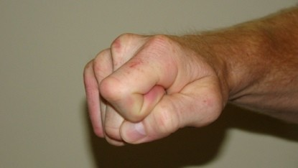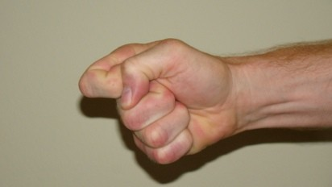
Shoken
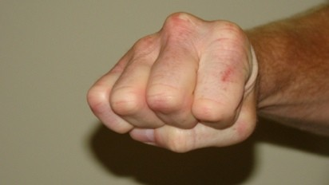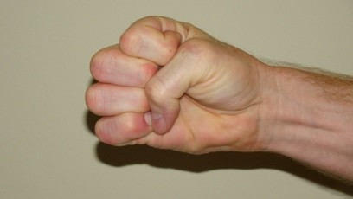
Hiraken
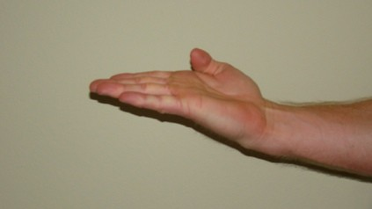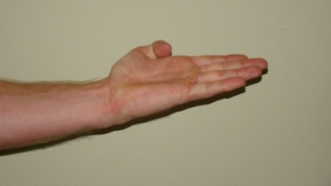
Nukite
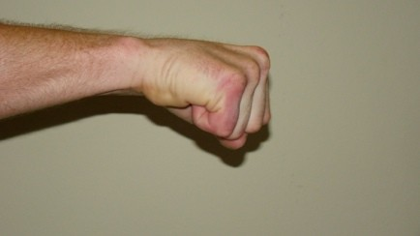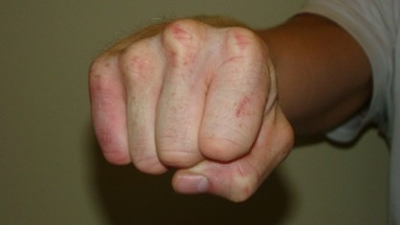
Seiken
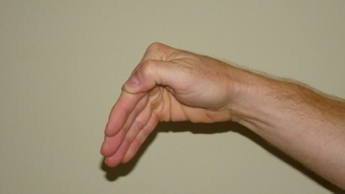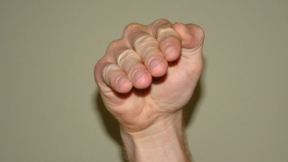
Kakushiken
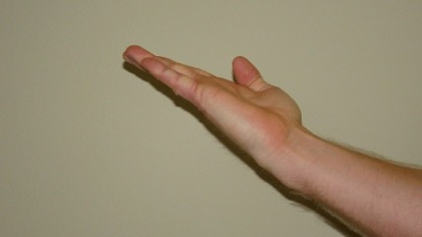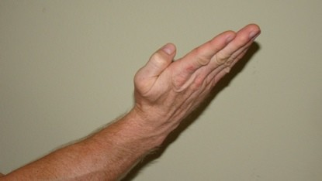
Shuto
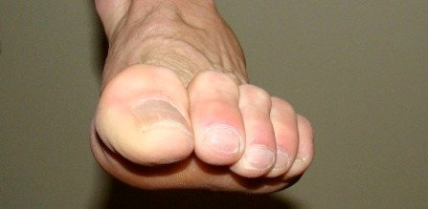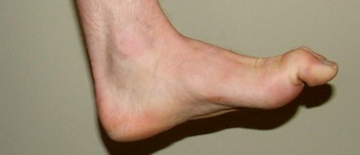
Sokusen
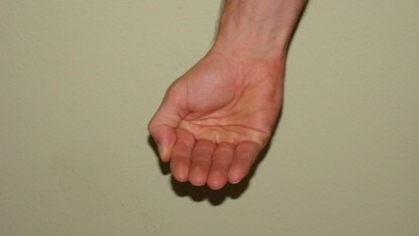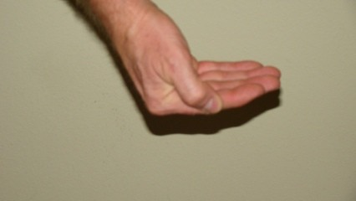
Kokken
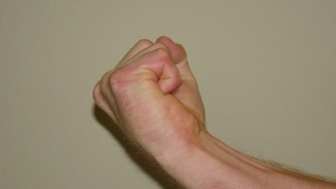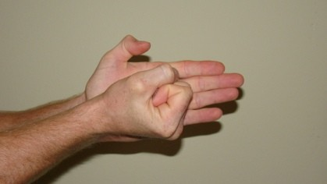
Tettsui
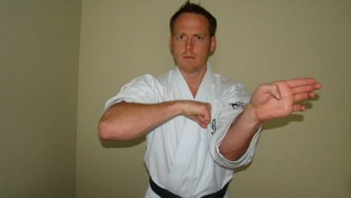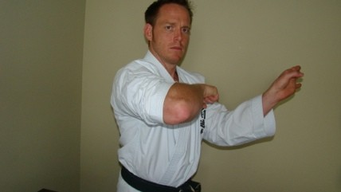
Hiji Tsutki

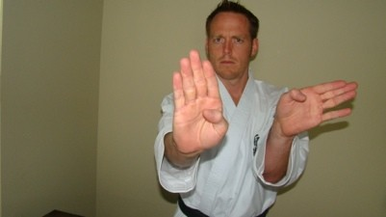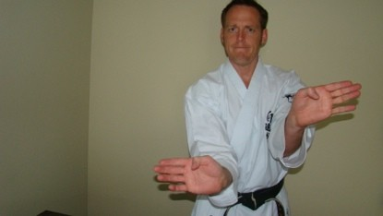

Bushiken
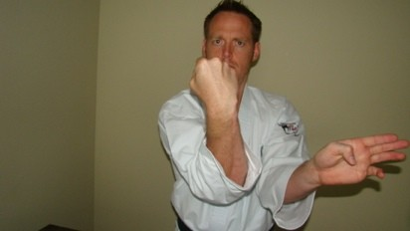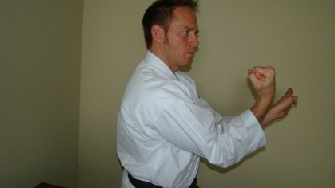

Reiken

General Knowledge Questions for White belt with Yellow Tip
- What is the name of the style of karate you are studying? Uechi Ryu Karate
- Who was the founder of this system? Master Kanbun Uechi
- Which three animals are mimicked in this style of martial arts? Tiger, Dragon, and Crane
- What is right foot forward called in Japanese? Migi ashi mae
- What is left foot forward? Hidari ashi mae
- What was Kanbun`s teachers name? Shushiwa
- What does the word karate mean?
Empty hand (unarmed self defense)
- What is your uniform called in Japanese? Gi
- What is your belt called in Japanese?Obi
- Count to 10 in Japanese.
1. Ichi (ee-chee), 2. Ni (Knee), 3. San (san), 4. Shi (she), 5.Go (go)
6. Roku (row-cooo) 7. Shichi (seat-chee) 8. Hachi (hot-chee) 9. Ku (cue) 10. Ju (jooo)

General Knowledge Questions for Yellow Belt
- What is the name of the first and most important Kata in our system? Sanchin Kata
- What does Sanchin mean? Three battles or conflicts
- What are the 5 purposes of Sanchin
- To build a strong body
- Consolidate the basic stance
- Master the proper breathing method
- Penetrating eye
- Develop spiritual concentration
- Where did Kanbun learn martial arts?Fukien Province of Southern China
- What was Master Kanbun`s sons name who did so much in regards to the development of the style? Master Kanei Uechi
- What is the name of the second kata taught in our system? Kanshiwa
- What is the one knuckle strike called in Japanese?
Shoken
- What is the spear hand strike called? Nukite
- What is the toe fist called?
Sokusen
- How long did Master Kanbun Uechi study in china?
13 years

General Knowledge Questions for Yellow belt with Green Tip
- What is the fist called? Seiken
- What is the punch called in Japanese? Tsuki
- What was the original name of the style when Kanbun learned it? Pangainoon
- What is the Japanese term for bowing? Rei
- What is the Japanese term for free sparring? Jiyu Kumite
- What are the words for pre arranged sparring drills? Yakusoku Kumite
- What year did Master Kanbun die? 1948
- What is the word for stop or break?
Yame
- What is the word for start or begin? Hajime
- What is arm conditioning called?
Kote Kotai

General Knowledge questions for Green Belt
- What is a Dojo?
A training hall where karate is practiced
- What does “Domo Arigato Gozai Mashta mean? Thank you very much
- What does “Go Kura Sama” mean? Thank you for your hard work
- What does Daichi mean? Stance
- What does Ryu mean? Style
- When was Kanbun Uechi born? May 5, 1877
- What were the original 3 katas taught in Uechi Ryu? Sanchin, Seisan, Sanseiryui
- What are thee three battles of Sanchin? Mind, Body, and Spirit
- In what year was the style formally named Uechi Ryu? 1949
- Why does Uechi Ryu include such strikes as the shoken and sokusen strikes?
To increase precision and penetration
General Knowledge questions for Green Belt with Blue Tip

- What is the name for leg pounding in Japanese? Ashi Kotae
- What is the name for the Japanese language in Japanese? Nihongi
- How do you say please watch this? Onegashimas
- What does the word kata mean? Form or pattern
- What animal does the wrist blocks come from? Crane
- From which animal art did Uechi Ryu`s style of breathing originate?Dragon
- How do you say excuse me in Japanese? Sumi Masen
- What 3 elements are students judged for in kata testing? Form, Strength, and Spirit
- What does panngainoon mean? Half hard and half soft
- What are the names of the 5 katas that Kanei Uechi introduced to Uechi ryu. Kanshiwa, Kanshu, Seichin, Seiryu, and Kanchin
General Knowledge for Blue Belt

At the end of Sanchin kata what is being symbolized by the left hand covering the right fist? The right fist is your ego and the left hand is exhibiting self control
- What year did Kanei Uechi begin his teaching? 1948
- What 3 principles are learned from studying kata?
1. To think before you act 2. To pay attention to detail 3. Finish what you start
- What is the meaning of Bushido or the Warrior Spirit? To train the mind, body, and spirit to be pure and strong
- In what year did Kanei Uechi die? 1991
- Who created the Sanchin Kata? Bodi Darma, an Indian priest
- What is Kick in Japanese? Geri
- What is the difference in a Sokuto kick and a Yoku kick?
Sokuto is a kick that is at a 45 degree angle using the outer blade of the foot to the attacker. The Yoko is a full side kick using the heel of the foot
- What is the Uechi Ryu breathing exercise called? Shinko Kiu
- What are the eye strikes called? Shomen hajike

General Knowledge questions for Blue Belt with Brown Tip
- What are knee strikes? Hiza geri
- What is roundhouse kick? Mawashi Geri
- What is the word used for hammerfist? Tettsui

- Where should the eyes be focused during Sanchin kata? Focused straight at eye level
- True/false You should always straighten the front foot prior to stepping during Sanchin kata.
True
- When performing the wauke block, which hand should start and finish low? The front foot side
- Which arm should you use during the thrust when performing Sanchin kata?
Off rear foot side

General Knowledge questions for Brown Belt
- What are the original 3 katas?Sanchin, Seisan. Sanseiryu
- What are the 5 master ranks?
Rokudan, Nanadan, Hachidan, Kyudan, Judan
- Explain the proper breathing technique during Sanchin.
- What does waza mean? Technique
- What would an attack to the head be called? Jodan
- What would an attack to the neck? Kubi
- To the middle? Chudan
- Lower area? Gedan
- What is the term for back kick? Ushiro

General Knowledge questions for Brown Belt with Black tip
- What does mushin mean? No mindness
- What does mawate mean? Turn around
- What does yoi mean?
Assume opening stance
- What does myeta mean? Its like I surrender
- What does bunkai mean? Application
- To throw or toss?
Nage
- In your words how has your study of karate made improvements in your life?
- What are your future goals in martial arts training?
- What does kime mean? Focus
- What does kyosugei mean?
Assume attention stance

Vocabulary Page
- ichi
- ni
- san
- chi
- go
- roku
- sichi
- hachi
- ku
- ju
rei = bow Hajime = go or start!
hojondo = warm up exercises yame = stop
tsuki = punch jiyu kumite = free sparring shomen tsuki = straight punch migiashimae = right mawashi tsuki = hook punch hidariashimae = left shoken tsuki = one knuckle strike kote kitae = arm pounding seiken = fist daichi - stance hiraken = 4 knuckle strike reiken = backfist bushiken = thumb palm strike kiai = shout of spirit shuto = chop tettsui = hammer fist geri = kick shomen geri = front kick mawashi geri = roundhouse kick
yoko geri = side kick sokuto geri = a kick off to a 45 degree zensoku geri = kick of front leg kosoku geri = kick off the back foot shomen hajike = eye strike uke = block mawashi uke = circle block wauke block = offensive circle block jodan uke = high block gedan uke = down block kime = focus
kata = formal sequence of self defense moves nukite = spear hand strike yakusoku kumite = pre arranged kumite

